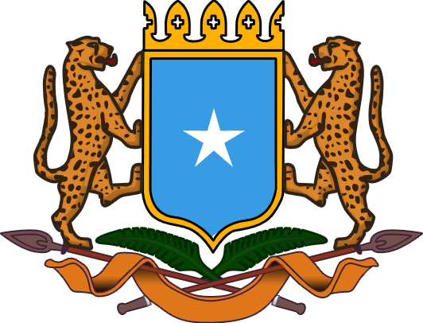

Jamhuuriyadda Federalka Soomaaliya

Wasaaradda Caafimaadka iyo Daryeelka Bulshada

Ref: MOH&HS/ODDMS/0147/Feb/2022 2/Feb/2022/ Mogadishu

Somali Federal Republic
Ministry of Health & Human Services
Director of Medical Services
XAFIISKA AG. WAAXDA DAAWEEYNTA, QALABKA IYO XARUMAHA CAAFIMAADKA

جمهــوريـة الصــومــال الفيــدرالية

وزارة الصحـــــــــــة ورعـــــــــاية المجتـــــــــمع

Subject: Health Facility Registration letter
This is to certify that the Ministry of Health and Human Services has hereby successfully registered Aadan Abdulle Hospital. The health facility was founded in 2007 and operating in Mogadishu Somalia. for the promotion of health care and providing approved services licensed by the Ministry of Health and Human Services.
This is a provisional registration for the purpose of a Specialist Hospital. Approved services only and it is valid from February 2, 2022 to February 2, 2023

Best regards

Dr. Abdulkadir Wehliye Afrah

Director of Medical Services, Federal Ministry of Health

