LIST OF COMMENTS FROM THE BOTH WEBSITE
NO | NAME | REMARKS
 | Sector Coordination (Link Correction)  (English version Website)  Please all sector coordination Document to be open in a new blank tap | 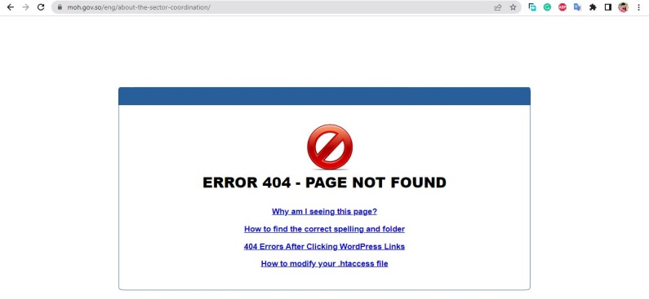  Sector Coordination (Please Connect the page)  (Fadlan dhamaan Documents ku jiro meeshaan waxa ay ku dhax furmaayaan website ee please waa in ay ku furmaan Blank tap oo website qofka uu san ka bixin )
 | For the news section, add see more option to preview all the news in one page | 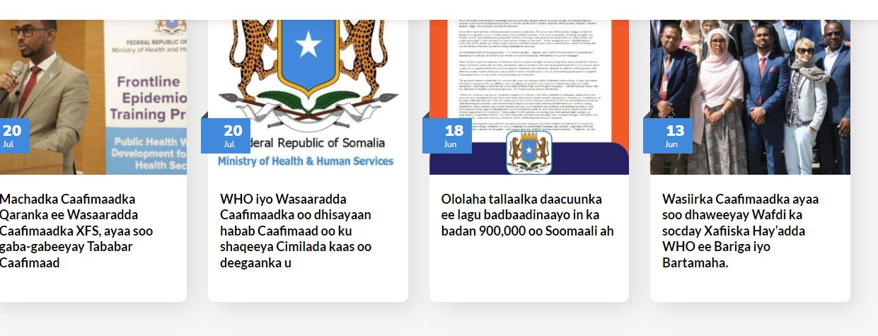  Here it only show last four news but there is 10 news’s in the website  (fadlan qaybta website waxaa ku jirto New badan marka fadlan waxaa muhiim ah in qofka uu arki dhamaan news)
 | Key Highlights section also add see more option to preview all the key Highlights | 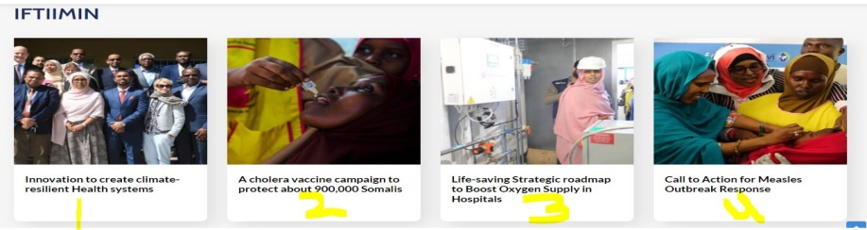  (fadlan Highlights tirade ayay ka bateen ilaa 7 xabo waaye lkn meeshaan waxa ka muuqdo afar xabo oo kaliya si loo arko dhamaan fadlan sameeya see more option am ka dhiga in uu move garoobo )
 | De- Martini Hospital name correction  (Vaccine location & center)  (Both Somali $ English ) | 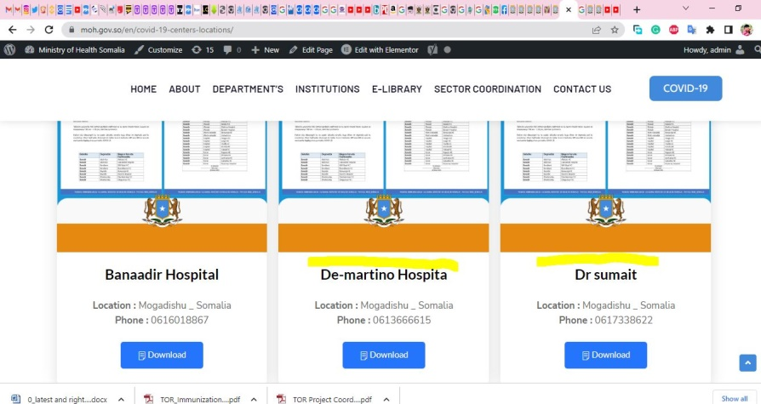  - BANADIR HOSPITAL  - DE-MARTINO HOSPITAL  - DR SUMAIT HOSPITAL  (fadlan magacyda saas ha u qormaan)
 | MAAMULKA IYO LACAGTA Change to MAAMULKA & MAALIYADDA  ADEEGA CAAFIMAADKA Change to DAAWEEYNTA, QALABKA IYO XARUMAHA CAAFIMAADKA | 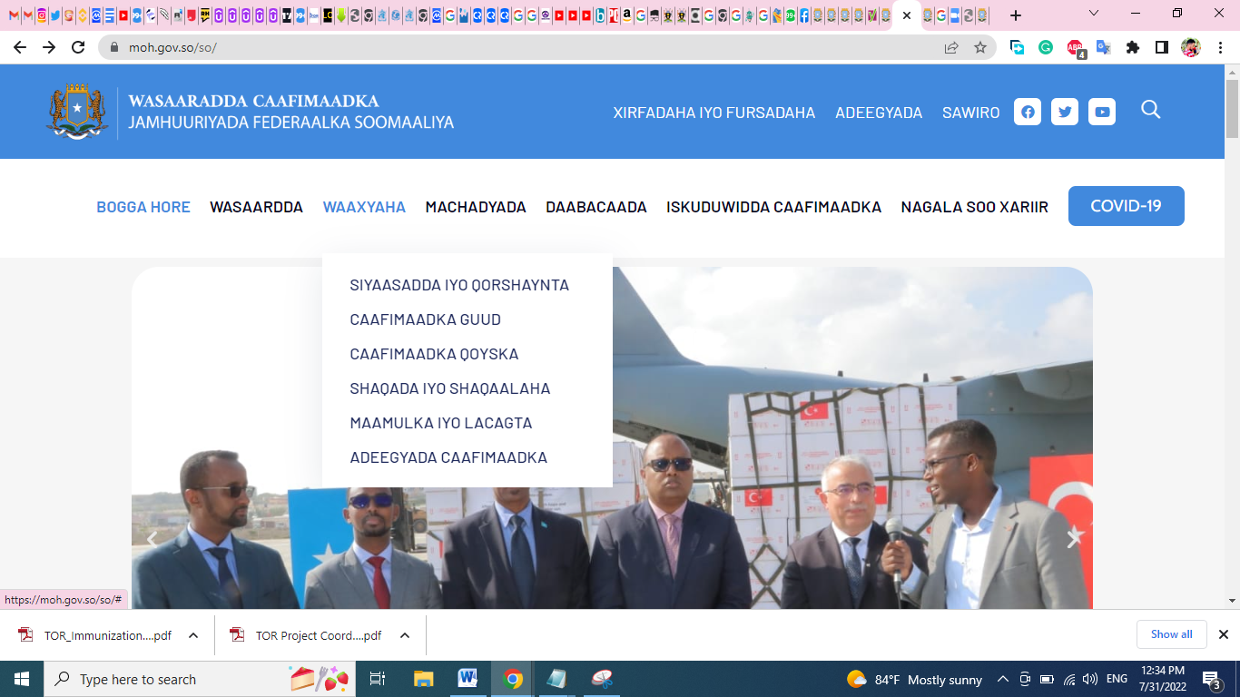  (fadlan website Soomaliga qaybta menu Waaxayaha maamulka Iyo lacagta ku badal, MAAMULKA IYO MAALIYADA)  Sidoo kale  ADEEGA CAAFIMAADKA ku badal  DAAWEEYNTA , QALABKA IYO XARUMAHA CAAFIMAADKA
 | Health Facilities (XARUMAHA CAAFIMAADKA)  Website Soomaliga Sub-Men Hospitals | 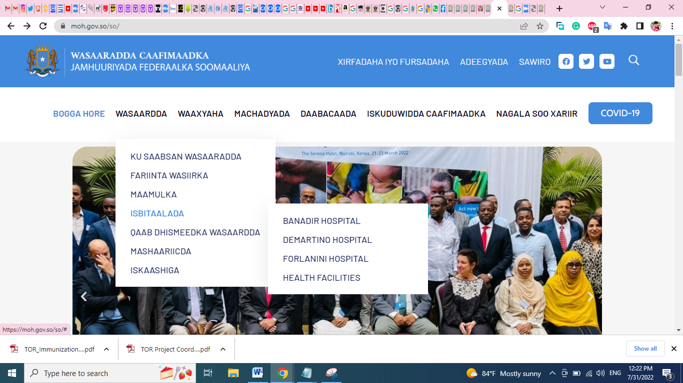  Qaybta Hopsitals ee Website Soomaliga ee health facilities ku badala XARUMAHA CAAFIMAADKA
 | Change MACHADKA to HAY'ADDAHA  (Website Soomaaliga) | Website Soomaliga
 | Events Small corrections  (Both Somali and English version) | 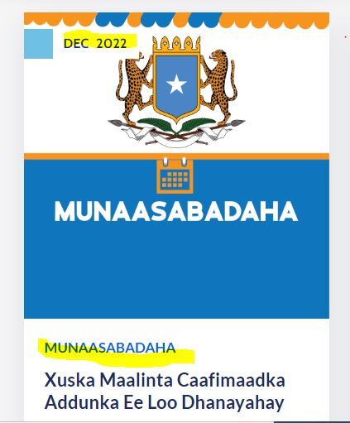  Remove all pointed Yellow items (Munsaabadaha , also upper date Dec 2022)  (Fadlan ka saara meelaha aan calamadeeyay ee jaalaha ah )  (fadlan Events maadaama ay yihiin kuwa sanadla,ah oo aan is badalayn waxaa la rabaa in ay u soo muuqdaan sida ay u kala horeeyaan , iyo in kuwa soo socdo ay ka soo muuqadaan website section)
 | Open a new tap | Dhaman website meel walba oo documents nuuc walba uu yahay sawier ama PDF, ku jiro waxaa laga rabaa in qofka aysan website ka saarin oo uu ku furmo New tap (Publication, Sector Coordination, Minsitry Structure, Institutions meel walba saas halaga dhigo.
 | Jobs listings | All location , to be default, All Category to be default , All Jobs types to be default (Dhamaan markii shaqada la soo galinaayo waa in ay dhamaan meelahaas ahaadaan Default oo aysan is badalin)  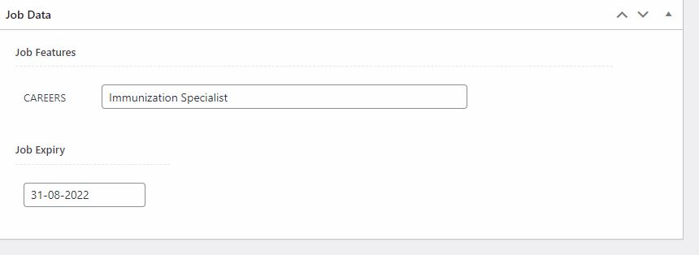  Remove careers (waa duplicate oo waxaa soo laabanayaa Title shaqada)    Markii shaqo la soo galiyo saan ayuu ku soo baxaa marka careers waa in meesha laga saaraa oo aysan soo muuqan.
 | IFTIIMIN Please change to QODOBADA MUHIIMKA | 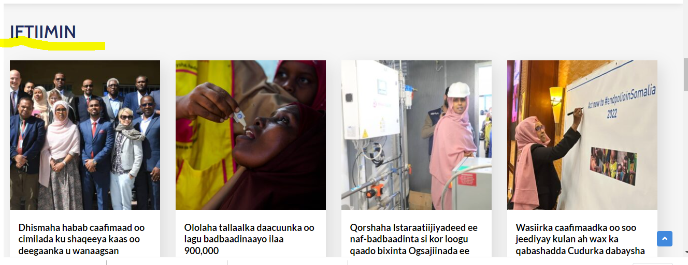
 | Search Bottom | Fadlan tusaale marka aad wax raadinayso waxa website dhaxdiisa ku jiro pages kakle oo tamplate watay kuwaas oo ka soo muuqanaayo searching Bottom Tusaale hadaad qorto RIO waxaa soo baxay dhawr page oo aan ahay kuwa Wasaradda oo lkn website ku dhax jira marka faldan dhamaan reomve dhaha all pages iyo Taps aan la istcimaalayn kaliya website haku haraan waxa aan istcimaalayno oo na quseeyo
 | Events | Maalintii u damabaysay waxaan soo diray Events oo English iyo Soomali ah waxa muhiim ah in marka koowaad website ugu jiraan sida ay u kala horeeyaan bu date kabacdi ay uga soo muuqadaan website section kuwa soo socdo
 | Web/admin Configuration | Madaama aad istcimaasheen website tamplate waxaa muhiim ah inaad dhamaan ka saartaan waxa aan la sictimaalayn oo dheeraad ah si hawsha ugu fududaato dadka xogta soo galinaayo oo aad ka saarataan waxaayaalah E-commerce iyo pages aan muhiimka ahayn
 | SEO | Yoast SEO Premium (Waxaa muhiim ah in website oo helo Yoast SEO Plugin kaas oo premium ah oo oo aad setup gaaraysaan sida heshiiska ahaana aad iibisiaan Fully Premium ah )
 | Coordination System | Waxaa la joogaa waqtigii aan bilaabi lahayn Systemka kale kaas oo aan filayno in meeting aan ka yeelano isbuucaan gaar ahaan maalmaha Talaado, arabaco si aan hawsha isla fiirino

END

