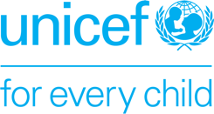
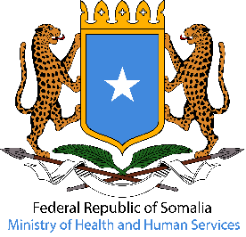
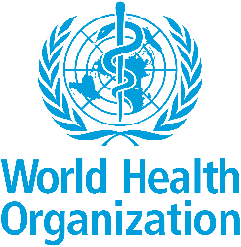

Somalia renews its commitment to end polio and ensure vaccination for every child

PRESS RELEASE
Somalia, 24 October 2024 – This World Polio Day, the Government of Somalia, the World Health Organization (WHO) and the United Nations Children’s Fund (UNICEF) reaffirm their commitment to safeguarding every child against polio, joining the global community to celebrate the progress made. Achieving and maintaining a polio-free world means every child would be safe from being paralyzed by this disease. ​

Today marks the profound achievements in immunization and calls on all stakeholders to fund and prioritize vaccines in 2024. Since the launch of the Global Polio Eradication Initiative in 1988, the incidence of polio has plummeted by 99 per cent, thanks to the widespread use of vaccines. Engagement by Somalia's Federal Ministry of Health, State leaders, communities, parents and caregivers has been vital to increase vaccination campaigns and support health workers.

“As we celebrate progress, we also recognize the critical work that remains. Incredible political commitment, demonstrated by the Prime Minister’s National Task Force on Immunization and Polio Eradication (SIPE), along with the active involvement of Ministers and State leaders in inaugurating polio campaigns, has been crucial in driving efforts to stop the current outbreak. The collaboration between the Somali government, health workers, and international partners is paving the way toward a polio-free Somalia,” said the Minister of Health and Human Services of the Federal Government of Somalia, Dr. Ali Haji Adam.

Somalia successfully stopped transmission of wild poliovirus in 2014. However, the country is now facing the world’s longest running outbreak of circulating variant poliovirus type 2. Additionally, over the years, the country has been facing recurrent measles and cholera outbreaks, spurred by drought and floods. This underscores the need for novel techniques to reach children in remote communities, expand vaccination coverage, and enhance the health system.

"On this important day, we recognize the significant progress Somalia has made in the fight against polio through sustained immunization efforts, even in the country’s most remote regions, and strengthened surveillance systems that protect our gains. We remain committed to ensuring Somalia stays on track toward a polio-free future and will continue to provide our support," remarked WHO Somalia Deputy Representative, Dr. Mohamed Ali Kamil.

Now is the time to end polio for good, but if we don’t stay committed, the virus could quickly make a comeback. To end the current transmission, Somalia has been streamlining efforts, using updated emergency action plans developed collectively by the FMOH and GPEI partners.

"On this World Polio Day, we reflect on our journey and renew our commitment to reach every last child. With the tools at our disposal, we must intensify our efforts, innovate new strategies to reach those we’ve missed, and strengthen routine immunization," said Nisar Syed, Officer in Charge, UNICEF Representative to Somalia. "No child should be paralyzed by or die from an illness that can be prevented through immunization. Investing in vaccines and a robust health system is a sure step to help protect the next generations."

Immunization is one of humanity’s most remarkable success stories. In the last 50 years, immunization efforts have saved thousands of lives and helped significantly reduce infant deaths across the country.​ Together, we will work to secure a polio-free future for all Somali children.

____________________________________
For additional information, please contact:

Mohamed Osman, FMoH Head of Comms & Public Engagement, communication@moh.gov.so
Khadar Hared, WHO Communication Officer, haredk@who.int
Lisa Hill, UNICEF Communications Specialist, lhill@unicef.org

